**Author** : Wiktor Łazarski

**Index number** : 281875

**Field of study** : Computer Science

**Faculty** : Electronics and Information Technology, Warsaw University of Technology

1. Task 1 : The machine precision
   1. Introduction.
   2. Algorithm description.
   3. Result.
   4. Testing obtain value.
2. Task 2 : Gaussian elimination with partial pivoting
   1. Introduction.
   2. Results.
3. Task 3 : Gauss-Seidel and Jacobi iterative algorithms
   1. Introduction.
   2. Results – Gauss-Seidel algorithm.
   3. Results – Jacobi algorithm.
   4. Summary.
4. Task 4 : Finding an eigenvalues
   1. Introduction.
   2. Results.
5. Appendices – MATLAB codes
   1. The machine precision.
   2. Gaussian elimination with partial pivoting implementation.
   3. Matrix A - generating functions for Task 2.
   4. Vector b - generating functions for Task 2.
   5. Determining the greatest *n* for Task 2.
   6. Calculating and plotting *r(n)* for Task 2.
   7. Research on residual correction for Task 2.
   8. Scripts used to research Jacobi and Gauss-Seidel algorithms.
   9. QR factorization.
   10. Finding eigenvalues using QR factorization without shifts.
   11. Finding eigenvalues using QR factorization with shifts.

**The first task** is to write a program which will find *the machine precision (macheps)* in MATLAB environment.

***The machine precision*** – the maximal possible relative error of the floating-point representation depends only on the number of bits of the mantissa.

Machine Epsilon can be understand also as an upper limit for the relative error in representation of the number. **abs ((x-y) / x) <= eps** where y is a machine representation of x. Epsilon can be used to determine the maximum error of an operation adding it to the arguments, and then see how it propagated in this operation.

1.2 Algorithm description

To determine machine precision the second definition, namely the definition of the unit round, will be used. The base ***P*** in the mathematical formula describing floating-point representation is 2. From that the minimal number ***g*** must be divisible by 2.

For that matter, our algorithm will be design using only ***while*** loop where in the block of it we will be dividing our variable (***macheps***) by 2 until the condition ***1 + macheps > 1***returns ***false***. After loop, we must multiply variable ***macheps***by 2 to obtain last “visible”, by computer, number – the unit round.

The Matlab implementation of that algorithm can be found in   
*Appendices.*

1.3 Result

Running the MATLAB script for computing machine precision the following solution was obtain :   
  


To test obtain value from proposed algorithm I applied two facts connected with machine precision, namely :

1. Matlab has an **eps** build-in function that returns the machine's epsilon and will be used for comparison. Obtained value :

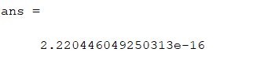

1. The relationship of the machine's epsilon with the number of bits used to represent the floating-point number, according to the IEEE 754 standard ,: epsilon corresponds to the number of positions in the mantissa. Two consecutive numbers can differ only by $2^{-t}$, where *t* indicates the number of bits in mantissa. According to Standard IEEE number of bits used in double precision numbers equals 52. Hence, the obtain value is :

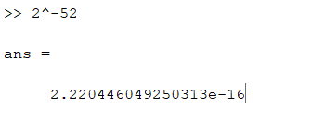

**Conclusion :** The results obtained are compatible what confirmed the correctness of my algorithm.

**The second task** is to write a program that will solve system of *n* linear equation **Ax = b** using Gaussian elimination with partial pivoting algorithm. Value of *n* is an every following number in a sequence 10, 20, 40, 80, 160, … . Matrix **A** and vector **b** are constructed based on the task specification (subpoints *a* and *b*).

Moreover, for subpoint *a* and *b*, *we* should :

1. Determine for which *n* algorithm will fail.
2. Calculate the vector of residuum **r = Ax – b**
3. Plot **r(n)**
4. For *n* = 10 print the solution and solutions’ errors vector and make residual correction to see whether it will improve the solution or not.

**Gaussian elimination algorithms** consists of two phases :

1. The Gaussian elimination phase – where we construct upper-triangular matrix.
2. The back-substitution – where the upper-triangular system of equations is solved.

Algorithm can be applied only for square matrices.

**The main drawback of standard version of Gaussian elimination algorithm** is a high possibility to get 0 at the diagonal line. In that case algorithm will perform division by 0 and the back-substitution phase will fail. To avoid such situation we should consider using *Gaussian elimination with partial pivoting* algorithm, which improves our previous one. The main difference is that before zeroing all the elements in a column we look for an element, in that column, that *mod(elem)* gives the greatest value. Then we swap rows so that our found element is on the diagonal line. After that operation, we are ready to perform zeroing the rest element in column exactly in the way we do it in a basic version of an algorithm. Computational complexity of this method is O($n^{3}$).

**It must be highlighted** that using *Gaussian elimination with partial pivoting* we must pick element in every iteration because it provides smaller numerical errors of the solutions’ vector.

Full implementation of an algorithm in Matlab as well as codes to generate matrices A and vectors b, for subpoint a an b can be found in *Appendices*.

The algorithm was tested by comparing the obtain values within the build-in Matlab operation, namely **A\b**. Both methods gave the same results what confirms the correctness of my algorithm.

**To determine the biggest *n*** for which algorithm works efficient I did an infinite *while* loop where inside the block I generate matrix *A* and vector *b* according to current *n* and I solve *Ax = b*. To see whether algorithm performed or not I print value of *n* at the end of the block. With my observation I can deduce that algorithm is effective for all *n*s in the sequence that are smaller than 2560.

Final answer : the last *n* for which we can say that algorithm is sufficient is **1280**.

However, we must point out that after some minutes of waiting result for *n* = 2560 also appeared on the console but that time was too long to be satisfied with an algorithm.

To check script see *Appendices*.

**The next issues** we had to researched and calculate were the Euclidean norm of the vector of the residuum *r* and plotting function *r(n)*. The results presents as follow.

**For subpoint a :**

|  |  |
| --- | --- |
| **n** | **||r||2** |
| 10 | 1.33e-15 |
| 20 | 2.71e-15 |
| 40 | 6.94e-15 |
| 80 | 1.85e-14 |
| 160 | 4.72e-14 |
| 320 | 4.72e-14 |
| 640 | 4.73e-13 |
| 1280 | 1.04e-12 |

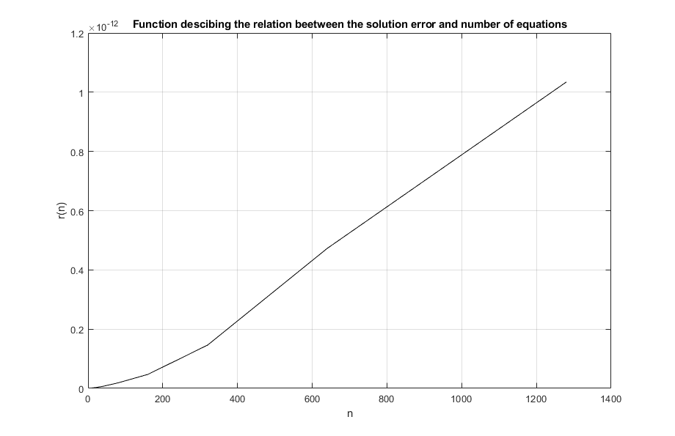

**Conclusions :** It can be seen from the plot that the result’s error increases non-linearly with the number of equations. Errors these are in range ${10}^{-12}$. For that matter, we can conclude that the obtained solutions for subpoint **a,** by this method, gives you exact results.

**For subpoint b :**

|  |  |
| --- | --- |
| **n** | **||r||2** |
| 10 | 1.67e-05 |
| 20 | 6.60 |
| 40 | 7.86 |
| 80 | 3.61 |
| 160 | 3.20 |
| 320 | 1.90 |
| 640 | 3.82 |
| 1280 | 8.29 |

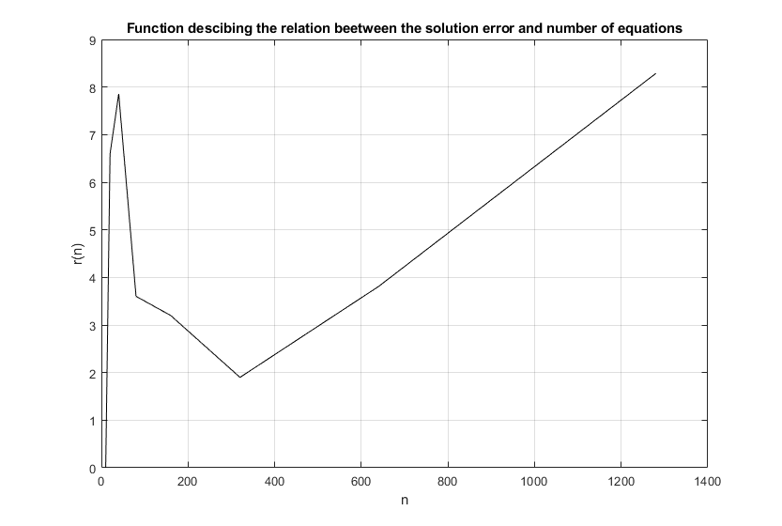

**Conclusions :** Errors increase more rapidly and are greater for subpoint **b** thanfor subpoint **a**. In my opinion, it is due to a fact that second formula of generating matrix **A** and vector **b** gives vastly diverse numbers smaller than one and reminds Hilbert’s matrix which is very characteristic for it’s ill-conditions. For that matter I can assume that the hole system is ill-conditioned. To check that hypothesis I used build-in function of the Matlab environment and I plot condition number of matrix **A** versus number of equation **n**.

n = 1:8;

curr_n = 10;

conds = zeros(1, 8);

for i = 1:8

A = genMatB(curr_n);

conds(i) = cond(A);

n(i) = curr_n;

curr_n = curr_n * 2;

end

plot(n, conds, 'k-');

xlabel('n'), ylabel('Condition number')

title('Function descibing the relation beetween the condition number of mat A and number of equations');

grid on;

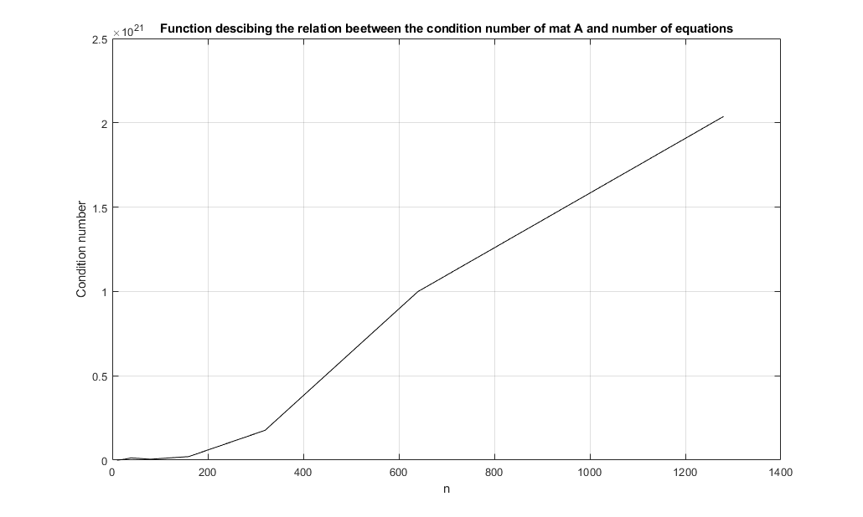

As expected condition number for that system is quite high, in range ${10}^{21}$.. It means that with this indicator we can expect proper solution within respect to two significant digits. Finally, after presenting the result we can conclude that the system is ill-conditioned, because small perturbation in data results in big differences in solution.

To check script see *Appendices*.

**Last part of task 2** is to make residual correction for n = 10 and check whether it makes any difference in solutions we received. The procedure of computing and adding received solutions’ errors vector should continue unless vector of residuum **r** will not increase with respect to previously received one.

**For subpoint a,** we can observe following results of norm of residuum vector with respect to iteration number :

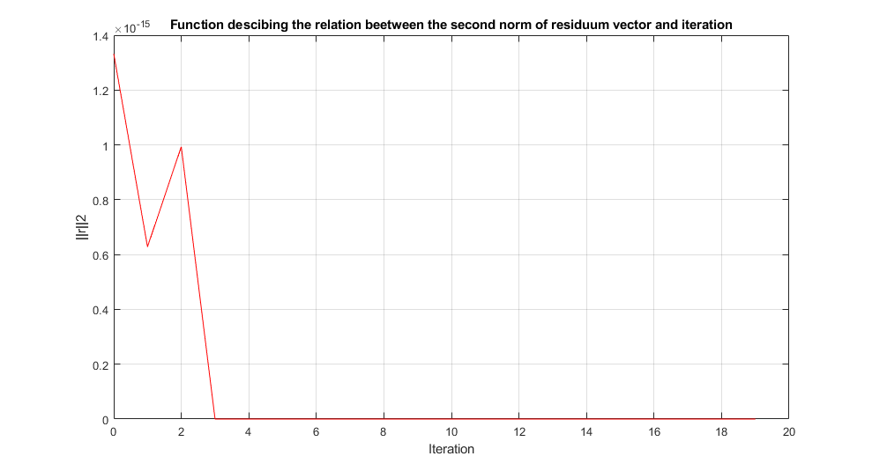

**Conclusions :** we can see that Euclidean norm of residuum vector in that case is convergent to zero and reaches it in third iteration. That means that system is not ill-conditioned and the value we receive is an proper result for the given system. The procedure of residuum correction, in this case, makes some improvement at the beginning but according to the range of first values of norms (${10}^{-15}$) it cannot be seen within the range of significant digits we are interested in.

**For subpoint b**, we can observe following results of norm of residuum vector with respect to iteration number :

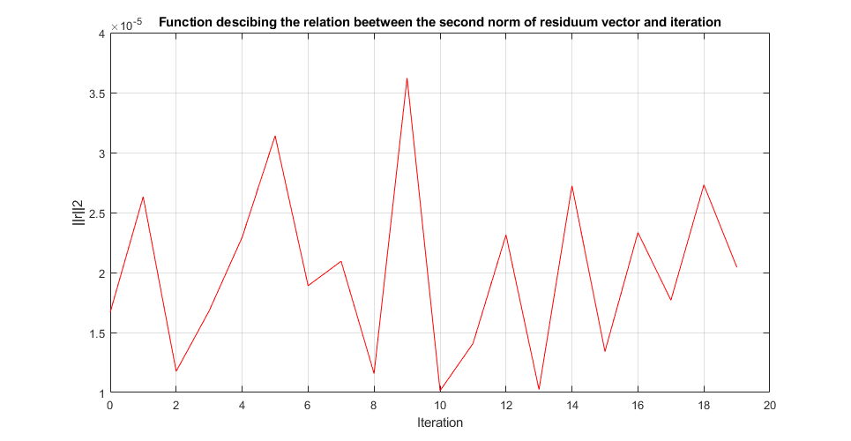**Conclusions :** first of all, we can see that norm of residuum vector significantly oscillate. It confirms our previous state that the system is ill-conditioned. It is impossible to receive proper value, because the presented function does not converge to 0. To pick the closest to the proper value result we should pick values of **x** in the iteration for which function presents minimal extreme. In our case it is clearly seen that it will be true for iteration number 10. Therefore the vector **x** before and after residual correction :

|  |  |
| --- | --- |
| No residual correction | Vector **x** after **10th** iteration |
| -3584761.14240360 | -3584734.77902376 |
| 308717756.036696 | 308715622.404151 |
| -6563602907.24927 | -6563559810.15203 |
| 59604806479.0308 | 59604431649.2258 |
| -284106899352.088 | -284105177614.312 |
| 780648311567.862 | 780643730237.491 |
| -1280395827070.67 | -1280388521746.83 |
| 1237070375094.74 | 1237063490949.18 |
| -649341591596.799 | -649338057684.721 |
| 142781782692.163 | 142781021025.339 |

In subpoint b, in opposite to subpoint a, we can observe some significant changes in received solution vector **x**.

**Remark** : We can see that in this and other iteration two first digit of obtain value never change. It confirms the state that we made when researching how Euclidean norm of residuum vector is related to number of equations, namely “*we can expect proper solution within respect to two significant digits*”.

To see script check *Appendices*.

**The third task** is to write a program that will solve system of *n* linear equation **Ax = b** using Gauss-Seidel and Jacobi iterative algorithms. We also have to make some research on how results obtained from a single iteration are related to iteration number by plotting second norm of solution error **ri** versus iteration number i = 1,2,3,… .

**General idea of iterative method** of solving **Ax=b** is that we consider a sequence of vectors **x(n)**, where *n* = 0, 1, … and x(0) is a given initial point, generated according to :

**x(i+ 1)** = **M x(i)** **– w**

where M is a certain matrix.

In order to be able to carry out the Gauss-Seidel or Jacobi iterative method, we first have to check does the matrix A satisfy the condition of sufficient convergence, i.e. strong diagonal domination (This means that the sum of all elements in the line outside the diagonal cannot be larger than a diagonal element). If this matrix does not satisfy the sufficient condition, we must check the necessary condition of convergence of each iterative method, i.e. spectral radius of the matrix **M** must be less than 1**.**.

When this condition is met, we can go to the matrix A distribution on the matrix:   
**L** - the subordinated matrix, **U** – matrix with elements over the diagonal and **D** – diagonal matrix. In the following way:

**A = L + D + U**

Single iteration of Gauss-Seidel algorithm we can write down :

**𝑥(𝑖+1) = (𝐷 + 𝐿)-1 (−𝑈 ∗ 𝑥(𝑖) + 𝑏); 𝑖 = 0, 1, 2, …**

Single iteration of Jacobi algorithm we can write down :

**𝑥(𝑖+1) = − 𝐷-1 (𝐿 + 𝑈) 𝑥(𝑖) + 𝐷-1 𝑏; 𝑖 = 0, 1, 2, …**

For this method, it is crucial to determine the stop test that, when it is fulfilled, is to cause stop iterating and write the result. In this case, it will be the assumed achievement accuracy given in task description it is **||ri||2 <** .

Full implementation of both algorithms in Matlab can be found in *Appendices*.

The algorithms were tested by comparing the obtain values within the build-in Matlab operation, namely **A\b**. Both methods gave the same results what confirms the correctness of my algorithms.

**Results after applying task data :**

|  |  |
| --- | --- |
| **A** = [6 2 1 -1;  4 -10 2 -1;  2 -1 8 -1;  5 -2 1 -8]; | **b** = [6;  8;  0;  2]; |

**Obtain vector x :**

|  |
| --- |
| **x** |
| 1.2877 |
| -0.4059 |
| -0.2952 |
| 0.6194 |

**The resulting plot :**

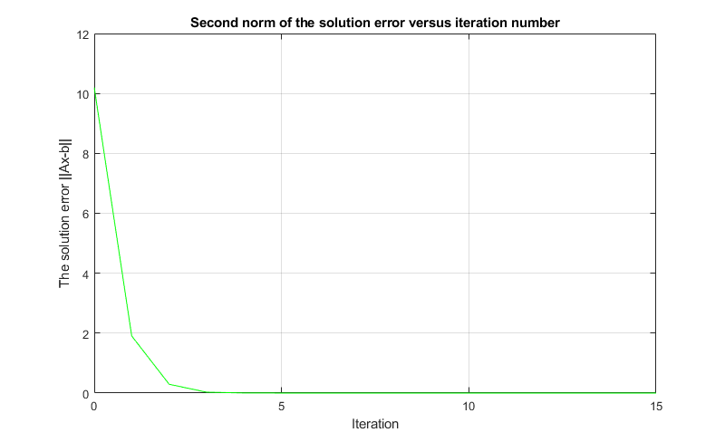

**Conclusions :** As we can see in the plot for a small number of iterations the solution error is large, but it decreases very rapidly as the number of iterations increases. For all iteration greater than 5 errors reach a value close to zero and the tendency to converge to zero keeps. For that matter, we can assumed that the Gauss-Seidel method gives in this case of very accurate results.

**After applying data formulated in Task 2** for *n* = 10, the ones from subpoint *a* were able to be solved using Gauss-Seidel algorithm in 29 iterations and gives the same result as by using Gaussian algorithm with partial pivoting. The data from subpoint *b* (*n* = 10) were much more interested. It occurred that it is impossible to solve them but the conditions of properly used Gauss-Seidel algorithm were fulfilled. In this case algorithm cannot solve this system in satisfying period of time. Firstly, I checked why do those data pass through conditions. It appeared that solution for that occurred when computing spectral radius of matrix *M*.Condition was fulfilled but the *sr(M)* was indicated to be 1 what gave me a contradiction. The reason lies down in numerical representation of the spectral radius. Computer on which I made researches knew that it was slightly smaller number than 1 but when it had to use it for any operation, as for example comparison, it simply treated those number as 1.

Resulting plot for the data from subpoint *a* :

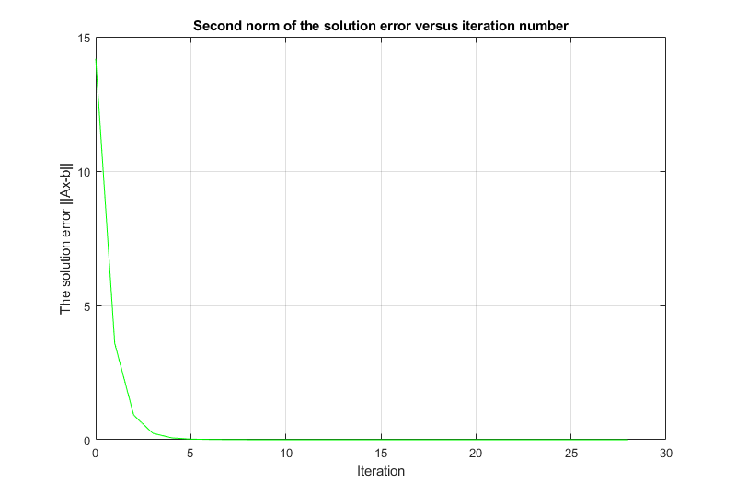

**Summary :**

|  |  |
| --- | --- |
| **Method** | **Number of iterations** |
| Task’s data | **16** |
| Data from subpoint *a* of Task 2 (*n = 10*) | **29** |
| Data from subpoint *b* of Task 2 (*n = 10*) | **Unsolvable** |

**Results after applying task data :**

**Obtain vector x :**

|  |
| --- |
| **x** |
| 1.2877 |
| -0.4058 |
| -0.2952 |
| 0.6194 |

**The resulting plot :**

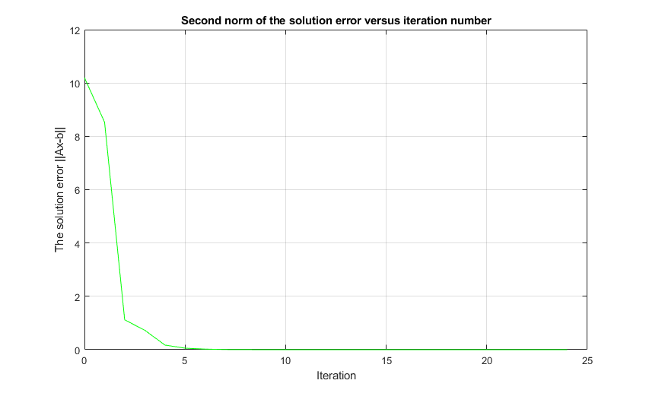

**Conclusions :** The conclusions can be written down exactly the same as for Gauss-Seidel algorithms. However, it is worth to spot that rapid decrease in the solution error is not as rapid as previously. It results in slower convergence to zero and we can see the first difference between algorithms that Jacobi one is less effective when it comes to comparing iteration performed. Number of iterations needed to be made in this method is 25 when previously was 16.

**After applying data formulated in Task 2** for *n* = 10, the ones from subpoint *a* were able to be solved using Gauss-Seidel algorithm in 59 iterations and gives the same result as by using Gaussian algorithm with partial pivoting. The data from subpoint *b* (*n* = 10) does not fulfilled the conditions for properly use of Jacobi algorithm therefore it was unable to see any results.

Resulting plot for the data from subpoint *a* :

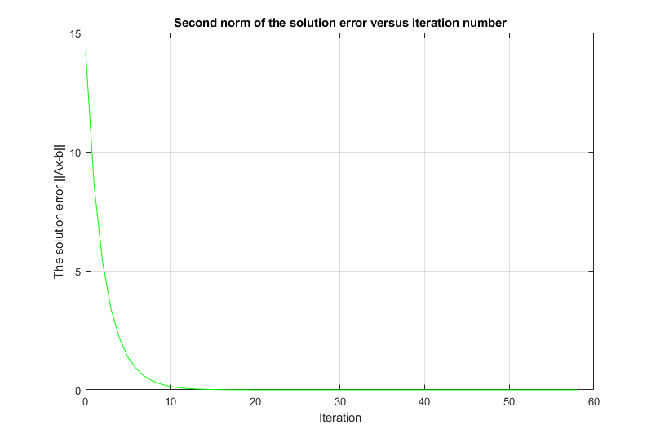

**Summary :**

|  |  |
| --- | --- |
| **Method** | **Number of iterations** |
| Task’s data | **25** |
| Data from subpoint *a* of Task 2 (*n = 10*) | **59** |
| Data from subpoint *b* of Task 2 (*n = 10*) | **Unsolvable** |

Comparing the two algorithms for solving systems of n linear equations, we can notice that the Gauss-Seidel method gives better results for the appropriate number of iterations(it needs twice less iterations) than Jacobi method, because of it is much faster. However, it is not as universal as the LU distribution method, which we can solve a much larger number of systems of equations. In our researches we were not able to solve systems with the data from subpoint *b* of Task 2. Therefore, the method Gauss-Seidel should be used for matrices that fulfill the appropriate conditions, while for others LU distribution method.

It is worth to mention that Jacobi method is a *parallel computational scheme*, because it’s matrix equation can be written in form of *n* independent scalar equations, which can be computed in parallel. For that matter, if we have machines that allows parallelization and we apply it we can spot huge improvement of Jacobi method which may results in better performance than Gauss-Seidel algorithm.

The forth task is to write a program for finding eigenvalues of 5x5 matrices using QR methods without and with shifts. We are obliged to make researches and compare how both approaches differs in terms of number of iterations needed to force all off-diagonal elements below the threshold ${10}^{-6}$.

**The QR distributio**n is based on the distribution of the matrix A (with linearly independent columns) on the matrix Q, which is a matrix with orthonormal columns, and R which is the upper and positive triangular matrix with elements on a diagonal.

**𝐴 = 𝑄𝑅**

The distribution of the matrix A is made by orthonormalizing the columns of matrix A and inserting them to matrix Q elements rii we insert to matrix R. The final step is to normalize vector Q and multiply matrix R by matrix N (from the left side), which contain norms of vectors on diagonal.

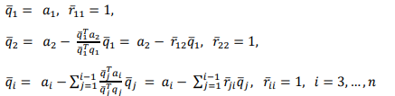

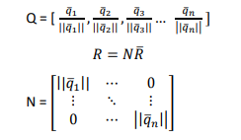

**QR method of finding the eigenvalues without shifts** presents as follow :

𝐴(1) = 𝐴

𝐴(1) = 𝑄(1)𝑅(1) (factorization)

𝐴(2) = 𝑅(1)𝑄(1) = ( 𝑄(1)𝑇𝐴(1)𝑄(𝑖))

𝐴(2) = 𝑄(2)𝑅(2) (factorization)

…

𝐴(𝑘) → 𝑉−1𝐴𝑉 = 𝑑𝑖𝑎𝑔{λ𝑖 }

**QR method of finding the eigenvalues with shifts** presents as follow :

𝐴(1) = 𝐴

𝐴(1) – *pkI*= 𝑄(1)𝑅(1) (factorization)

𝐴(2) = 𝑅(1)𝑄(1) + *pkI*

𝐴(2) = 𝑄(2)𝑅(2) (factorization)

…

𝐴(𝑘) → 𝑉−1𝐴𝑉 = 𝑑𝑖𝑎𝑔{λ𝑖 }

where *pk*  is the closest eigenvalue from submatrix 2x2 taken from right bottom corner of matrix 𝐴(k) . After resetting the remaining elements of the last column and the last row, we receive the eigenvalue in the bottom right of the matrix. The next step is taken include the matrix minus the last column and row.

Full implementation of both algorithms in Matlab can be found in *Appendices*.

The algorithms were tested by comparing the obtain values within the build-in Matlab function, namely **eig** and **qr**. My function of performing QR factorization gave the same works consistent with **qr** function and both methods of finding eigenvalues gave the same results as **eig** method what confirms the correctness of all my algorithms.

**The symmetric matrix A** that I choose for researches is as follow :

**A** = [88 1 19 1 11;

1 2 1 1 1;

19 1 3 14 1;

1 1 14 4 12;

11 1 1 12 5];

|  |  |  |
| --- | --- | --- |
|  | **Without shifts** | **With shifts** |
| **Number of iterations** | **81** | **7** |

**Matrix A after applying method without shifts** :

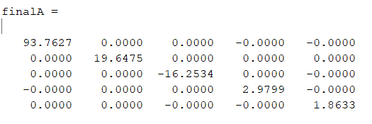

**Matrix A after applying method with shifts** :

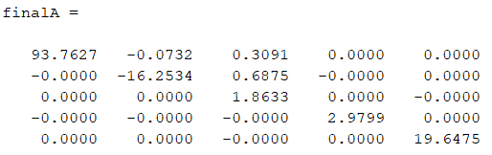

**Final obtained** vectors of eigenvalues presents as follow :

|  |  |  |
| --- | --- | --- |
| From **eig()** build-in function | QR factorization without shifts | QR factorization with shifts |
| -16.2534  1.8633  2.9799  19.6475  93.7627 | 93.7627  19.6475  -16.2534  2.9799  1.8633 | 93.7627  -16.2534  1.8633  2.9799  19.6475 |

**Conclusions :**  the QR factorization in the version without shifts requires a much larger number of iterations. It will not work for asymmetric matrices. Algorithm in the version with shifts requires less computational effort, despite the greater complexity of each step, because it converges much faster. It is also more universal due to support for asymmetric matrices.

%The script determines the machine epsilon

macheps = 1.0;

%Computing the machine epsilon based on the unit round definition

while 1.0 + macheps > 1.0

macheps = macheps / 2;

end

%We must multiply times 2 to get last 'visible' in addition value

macheps = macheps * 2;

disp(['The machine epsilon = ', num2str(macheps, 50)])

clear

%Function solves Ax = b. N is the size of matrix A.

function [x] = solveWithIndicatedMethod(A, b, N)

%Append solution to matrix A

A = [A b];

for i = 1:N-1

%Find the row with maximal abs value at current central element

curr_max = A(i, i);

row = i;

for j = i+1:N

if curr_max < abs(A(j, i))

row = j;

curr_max = abs(A(j, i));

end

end

%Swap rows if needed

if row ~= i

temp = A(i,:);

A(i,:) = A(row,:);

A(row,:) = temp;

end

%The Elimination phase of Gaussian algorithm

for j = i+1:N

curr_l = A(j, i) / A(i, i);

for k = i:N+1

A(j, k) = A(j, k) - curr_l * A(i, k);

end

end

end

%The back-substitution phase

x = zeros(N, 1); %vector of solutions

for i = N:-1:1

row_sum = 0;

for j = 1:N

row_sum = row_sum + A(i, j) * x(j);

end

x(i) = (A(i, N+1) - row_sum) / A(i, i);

end

end

%The function generates the matrix A for subpoint a.

function [retv] = genMatA(N)

retv = zeros(N);

for i = 1:N

for j = 1:N

if i == j

retv(i, j) = 9;

elseif i == j - 1 || i == j + 1

retv(i, j) = 3;

end

end

end

end

%The function generates the matrix A for subpoint b.

function [retv] = genMatB(N)

retv = zeros(N);

for i = 1:N

for j = 1:N

retv(i, j) = 2 / (3 * (i + j - 1));

end

end

end

%The function generates the solution vector b for subpoint a.

function [retv] = genSolVecA(N)

retv = 1:1:N;

for i = 1:N

retv(i) = 1.5 + 0.5 * i;

end

retv = transpose(retv);

end

%The function generates the solution vector b for subpoint b.

function [retv] = genSolVecB(N)

retv = 1:1:N;

for i = 1:N

if mod(i, 2) == 1

retv(i) = 0;

else

retv(i) = 1 / i;

end

end

retv = transpose(retv);

end

curr_n = 10;

while 1 == 1

%Generates proper input for current subpoint

A = genMatB(curr_n);

b = genSolVecB(curr_n);

%Solves Ax = b using the indicated method

x = solveWithIndicatedMethod(A, b, curr_n);

curr_n = curr_n * 2

end

n = 1:8;

r = 1:8;

curr_n = 10;

for i = 1:8

%Generates proper input for current subpoint

A = genMatB(curr_n);

b = genSolVecB(curr_n);

%Solves Ax = b using the indicated method

x = solveWithIndicatedMethod(A, b, curr_n);

%The solution error defined as the 2nd vector norm of residuum vec

r(i) = vecnorm(A * x - b);

n(i) = curr_n;

curr_n = curr_n * 2;

end

plot(n, r, 'k-');

xlabel('n'), ylabel('r(n)')

title('Function descibing the relation beetween the solution error and number of equations');

grid on;

curr_n = 10;

%Generates proper input for current subpoint

A = genMatB(curr_n);

b = genSolVecB(curr_n);

%Solves Ax = b using the indicated method

x = solveWithIndicatedMethod(A, b, curr_n);

results = x;

residuums = vecnorm(A * x - b);

for i = 1:20

r = A * x - b;

dx = solveWithIndicatedMethod(A, r, curr_n);

x = x - dx;

results = [results x];

if i ~= 1

residuums = [residuums vecnorm(r)];

end

end

plot(0:1:19, residuums, 'r-');

xlabel('Iteration'), ylabel('||r||2')

title('Function descibing the relation beetween the second norm of residuum vector and iteration');

grid on;

%Function checks if matrix A is strongly column dominant.

%N is the size of A

function [retv] = checkColDominance(A, N)

for i = 1:N

sum = 0.0;

for j = 1:N

if i == j

continue;

end

sum = sum + abs(A(j, i));

end

if abs(A(i, i)) <= sum

retv = false;

return;

end

end

retv = true;

end

%Function checks if matrix A is strongly row dominant.

%N is the size of A

function [retv] = checkRowDominance(A, N)

for i = 1:N

sum = 0.0;

for j = 1:N

if i == j

continue;

end

sum = sum + abs(A(i, j));

end

if abs(A(i, i)) <= sum

retv = false;

return;

end

end

retv = true;

end

%Function performed decomposition needed to perform iterative algorithms of

%solving Ax=b. N is the dimension of matrix A.

function [L, D, U] = decomposeMatrix(A, N)

L = zeros(N, N);

for i = 2:N

for j = 1:i-1

L(i, j) = A(i, j);

end

end

D = zeros(N, N);

for i = 1:N

D(i, i) = A(i, i);

end

U = zeros(N, N);

for i = 1:N-1

for j = i+1:N

U(i, j) = A(i, j);

end

end

end

%GAUSS-SEIDEL ALGORITHM

%Task's data

A = [6 2 1 -1;

4 -10 2 -1;

2 -1 8 -1;

5 -2 1 -8];

b = [6; 8; 0; 2];

% A = genMatB(10);

% b = genSolVecB(10);

N = 4;

[L, D, U] = decomposeMatrix(A, N);

%Checking the convergence condition

if ~(checkColDominance(A, N) || checkRowDominance(A, N))

invSumDL = inv(D + L);

spec_rad = max(abs(eig(invSumDL *(-U))));

if spec_rad >= 1

return;

end

end

invSumDL = inv(D + L);

%Initial guess

x = zeros(N, 1);

iter_cnt = 1;

sol_err = vecnorm(A*x - b);

while sol_err(iter_cnt) > 10^-10

x = invSumDL * (-U * x + b);

iter_cnt = iter_cnt + 1;

if iter_cnt ~= 1

sol_err = [sol_err, vecnorm(A*x - b)];

end

end

plot(0:iter_cnt-1, sol_err, 'r-');

xlabel('Iteration'); ylabel('The solution error ||Ax-b||');

title('Second norm of the solution error versus iteration number');

grid on;

&JACOBI ALGORITHM

%Task's data

A = [6 2 1 -1;

4 -10 2 -1;

2 -1 8 -1;

5 -2 1 -8];

b = [6; 8; 0; 2];

%A = genMatA(10);

%b = genSolVecA(10);

N = 4;

[L, D, U] = decomposeMatrix(A, N);

%Checking the convergence condition

if ~(checkColDominance(A, N) || checkRowDominance(A, N))

spec_rad = max(abs(eig(-inv(D)*(L+U))));;

if spec_rad >= 1

return;

end

end

%Initial guess

x = zeros(N, 1);

invD = inv(D);

iter_cnt = 1;

sol_err = vecnorm(A*x - b);

while sol_err(iter_cnt) > 10^-10

x = -invD * (L+U) * x + invD * b;

iter_cnt = iter_cnt + 1;

if iter_cnt ~= 1

sol_err = [sol_err, vecnorm(A*x - b)];

end

end

plot(0:iter_cnt-1, sol_err, 'r-');

xlabel('Iteration'); ylabel('The solution error ||Ax-b||');

title('Second norm of the solution error versus iteration number');

grid on;

%Function performs QR factorization on matrix A.

%N indicates the size of matrix A.

function [Q, R] = QRfactorization(A, N)

Q = zeros(N, N);

R = zeros(N, N);

d = zeros(1, N);

for i = 1:N

Q(:, i) = A(:, i);

R(i, i) = 1;

d(i) = Q(:, i)' * Q(:, i);

for j = i+1:N

R(i, j) = (Q(:, i)' * A(:, j)) / d(i);

A(:, j) = A(:, j) - R(i, j) * Q(:,i);

end

end

for i = 1:N

dd = norm(Q(:,i));

Q(:, i) = Q(:, i) / dd;

R(i, i:N) = R(i, i:N) * dd;

end

end

% Function performs QR method of finding eigenvalues without % shifts of matrix A

% N - the size of matrix A

% eigval - vector of eigenvalues

% iterCnt - number of iterations performed

% finalMat - matrix A after procedure

function [eigval, iterCnt, finalMat] = eigvalQRNoShift(A, N)

iterCnt = 0;

while max(max(A-diag(diag(A)))) > 10^-6

[Q, R] = QRfactorization(A, N);

A = R * Q;

iterCnt = iterCnt + 1;

end

eigval = diag(A);

finalMat = A;

end

% Function performs QR method of finding eigenvalues with shifts of matrix A

% N - the size of matrix A

% eigval - vector of eigenvalues

% iterCnt - number of iterations performed

function [eigval, iterCnt, finalA] = eigvalQRWithShift(A, N)

iterCnt = 0;

eigval = diag(A);

initSubmatrix = A;

for k = N:-1:2

cp = initSubmatrix;

while max(abs(cp(k, 1:k-1))) > 10^-6

DD = cp(k-1:k, k-1:k);

[ev1, ev2] = quadpolynroots(1, -(DD(1,1) + DD(2,2)), DD(2,2) * DD(1,1) - DD(2,1) * DD(1,2));

if abs(ev1 - DD(2, 2)) < abs(ev2 - DD(2, 2))

shift = ev1;

else

shift = ev2;

end

DP = cp - eye(k) * shift;

[Q, R] = QRfactorization(DP, size(DP, 1));

cp = R * Q + eye(k) * shift;

iterCnt = iterCnt + 1;

end

eigval(k) = cp(k, k);

A(1:k, 1:k) = cp(1:k, 1:k);

if k > 2

initSubmatrix = cp(1:k-1, 1:k-1);

else

eigval(1) = cp(1, 1);

end

end

finalA = A;

end